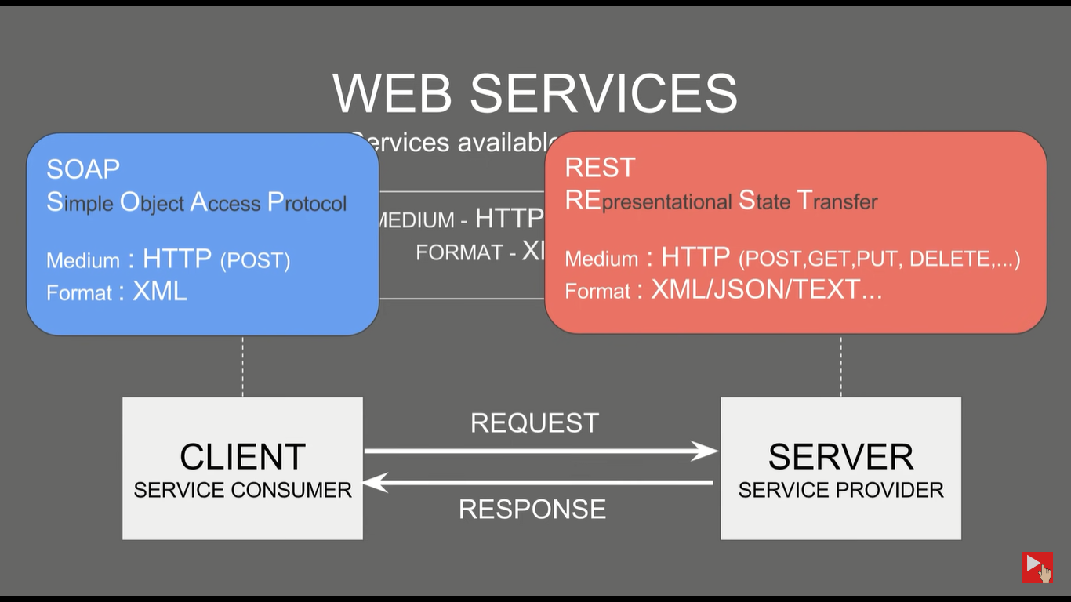

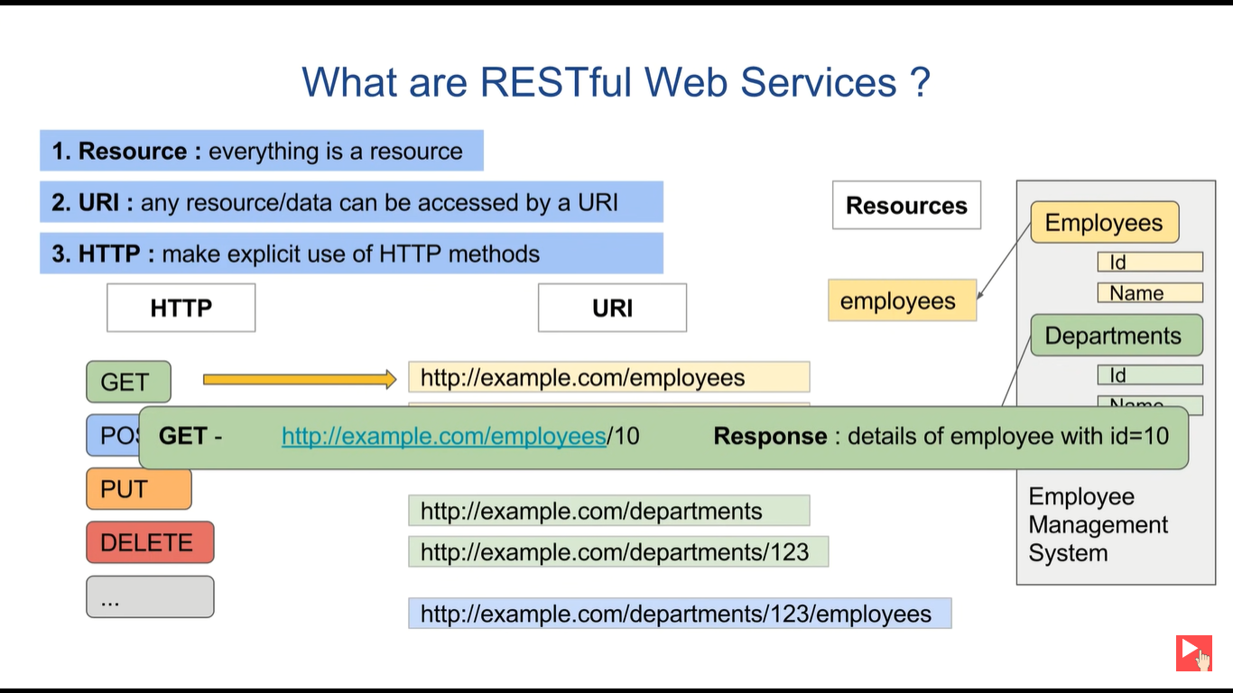

<http://www.thomas-bayer.com/sqlrest>

<http://www.thomas-bayer.com/sqlrest/CUSTOMER>

<http://www.thomas-bayer.com/sqlrest/CUSTOMER/10>

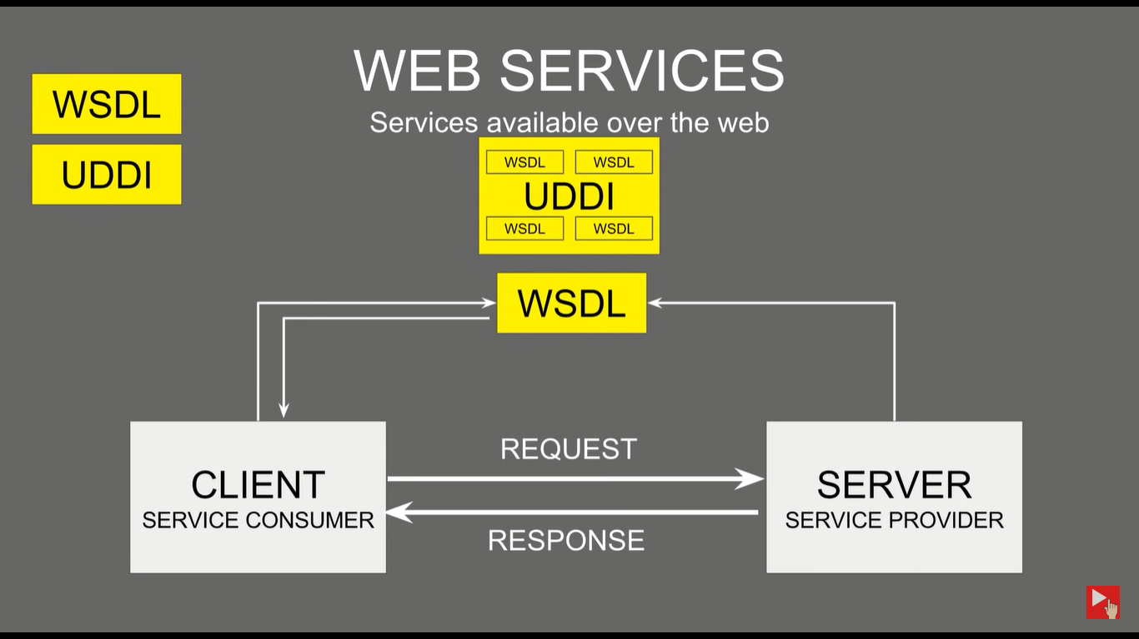

ONLINE WSDL DOCUMENT

Webserviceex.net